**FOLLOW THESE INSTRUCTIONS :**

Select “Circuit design Scale 12.0.1”

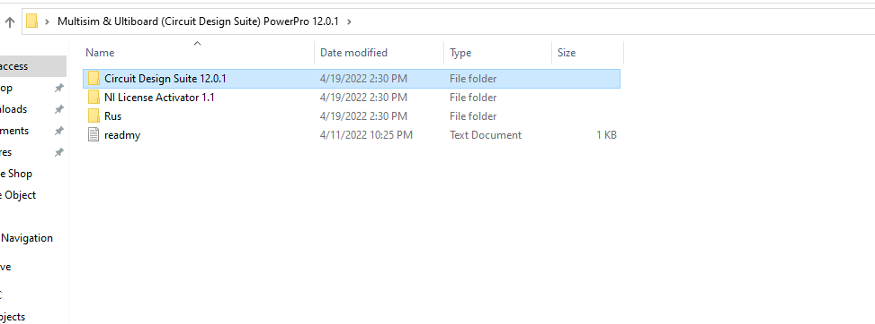

Press setup.

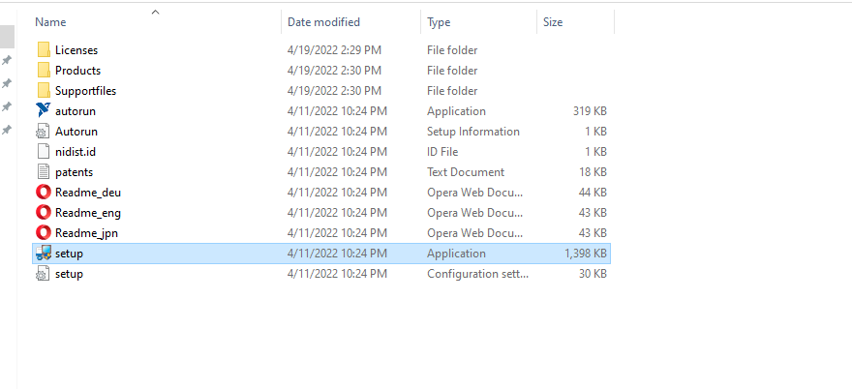

You will see this window.

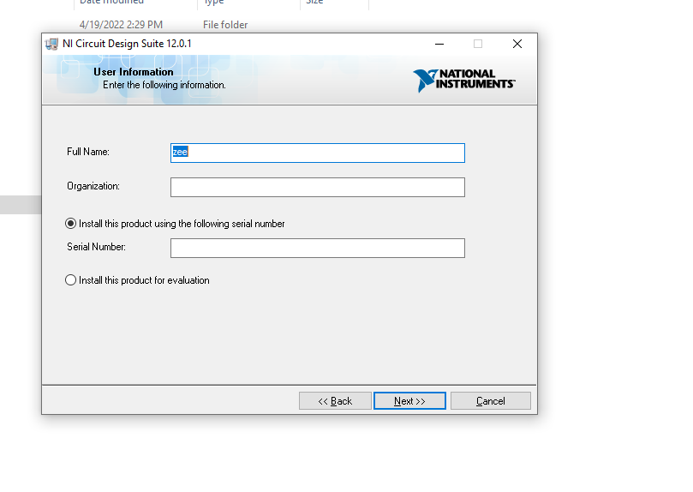

Keep the above window open.

Now go to “NL License”

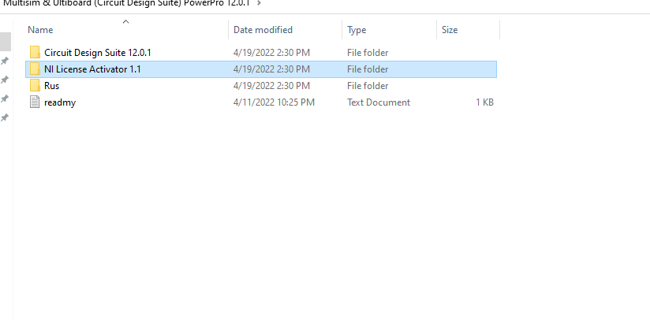

And select this option.

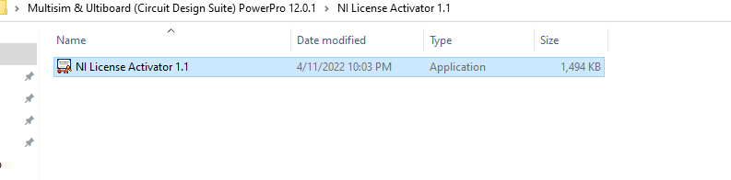

You will see this window :

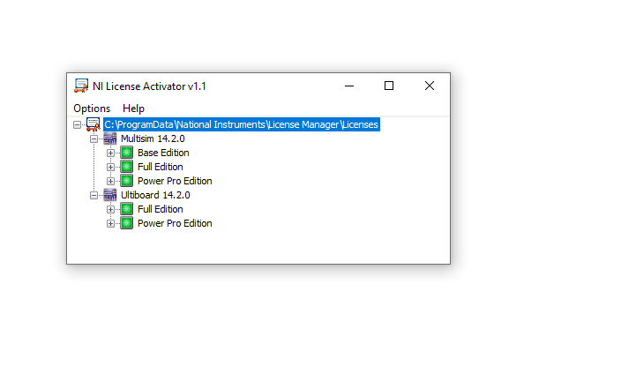

Click options and Press Generate Serial License.

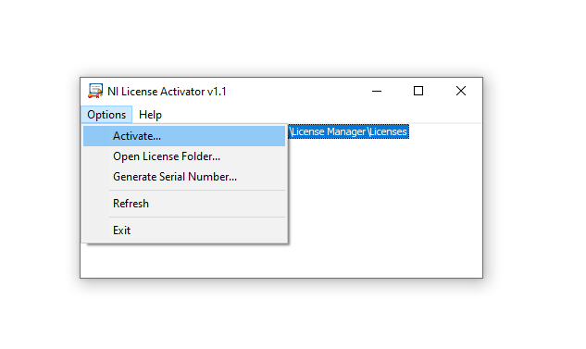

You will get a serial number. Copy it

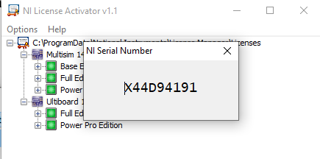

And paste in the serial number block.

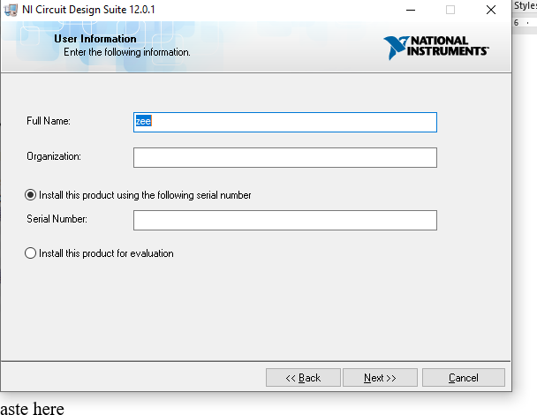

You can leave the organization box empty .Now, Press next.

Keep on pressing next. Ignore any error etc message. Eventually you will see this window.

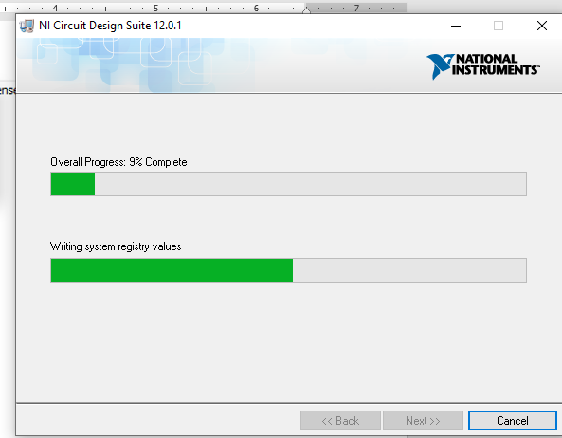

After you have installed it.

Go back here and press activate

